Test Case: tc001_SPX_Dev5_Crear_Solicitud_Articulo_Almacen
Step 1 - Enter username and password and click to button Enter : Credentials Entered
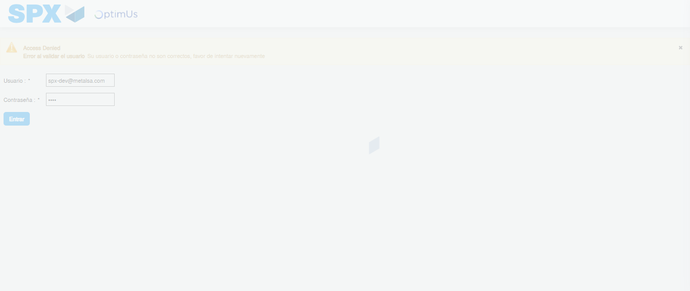Image file-name: QC_Testing-tc001_SPX_Dev5_Crear_Solicitud_Articulo_Almacen-1787938877818

Step 2 - Select to UEN and Access to Request for a New Inventory Item : UEN Correctly selected and Correct access
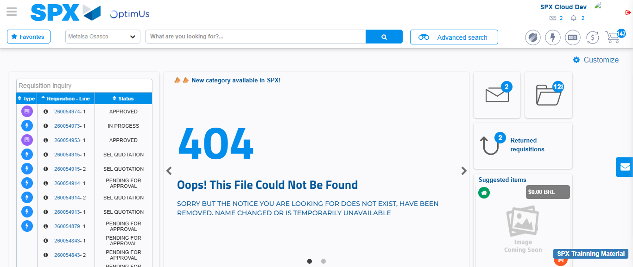Image file-name: QC_Testing-tc001_SPX_Dev5_Crear_Solicitud_Articulo_Almacen-1787938904006

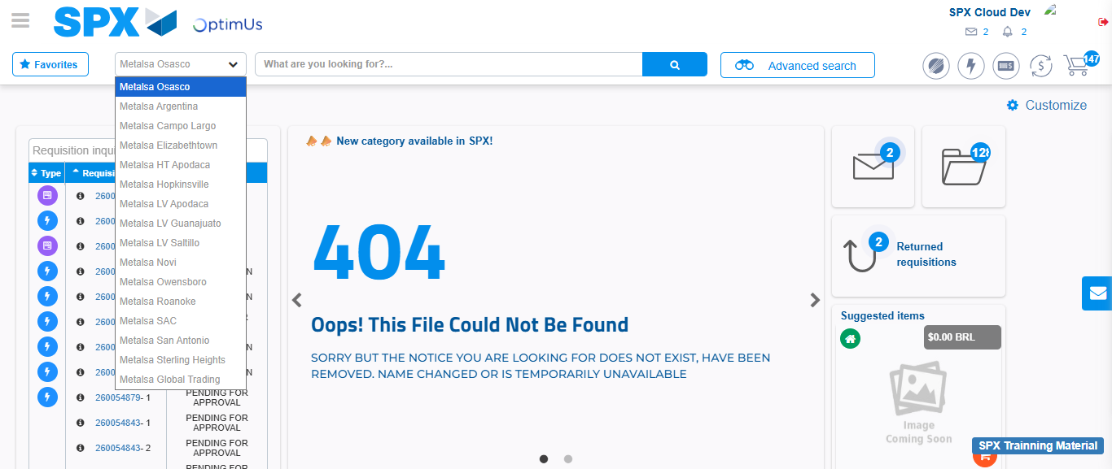Image file-name: QC_Testing-tc001_SPX_Dev5_Crear_Solicitud_Articulo_Almacen-1787938904605

Image file-name: QC_Testing-tc001_SPX_Dev5_Crear_Solicitud_Articulo_Almacen-1787938929099

Step 3 - Select options first section : Options seleted correctly
Image file-name: QC_Testing-tc001_SPX_Dev5_Crear_Solicitud_Articulo_Almacen-1787938929381

Image file-name: QC_Testing-tc001_SPX_Dev5_Crear_Solicitud_Articulo_Almacen-1787938929564

Step 4 - Select options at Screen: Options seleted correctly
Image file-name: QC_Testing-tc001_SPX_Dev5_Crear_Solicitud_Articulo_Almacen-1787938929381

Image file-name: QC_Testing-tc001_SPX_Dev5_Crear_Solicitud_Articulo_Almacen-1787938929564

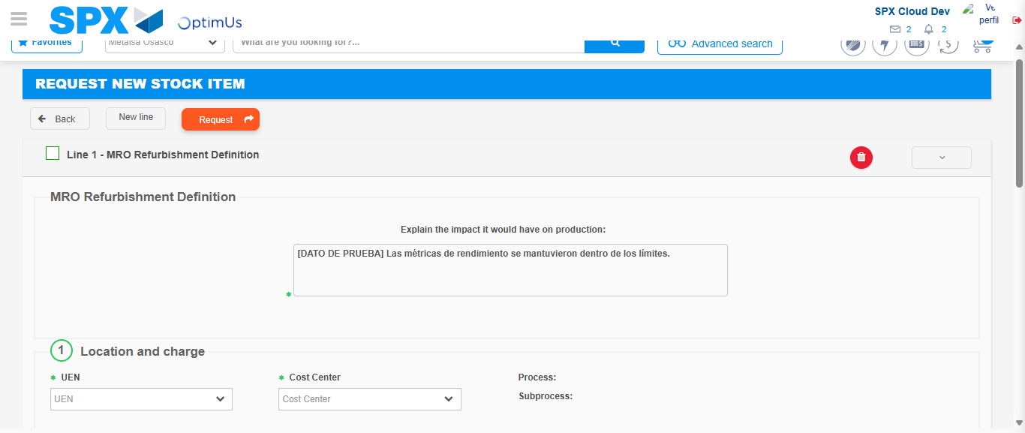Image file-name: QC_Testing-tc001_SPX_Dev5_Crear_Solicitud_Articulo_Almacen-1787938939421

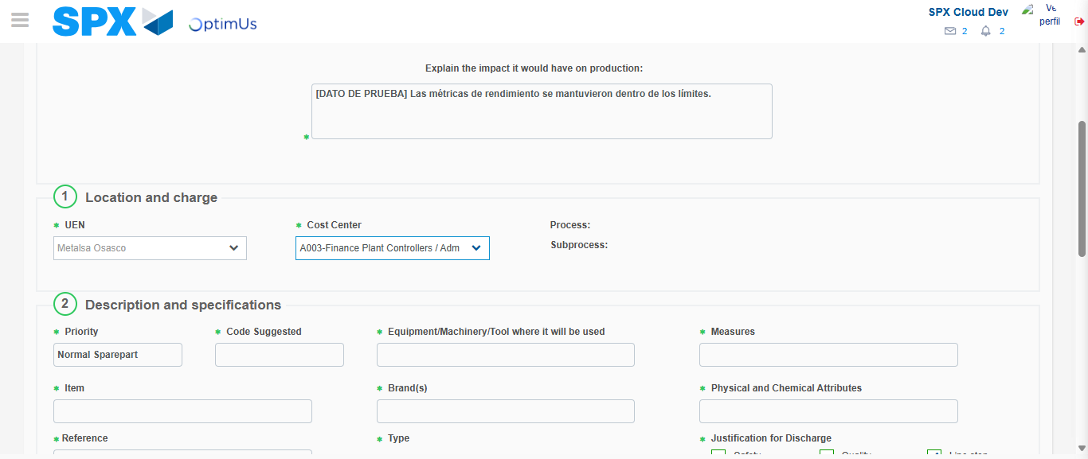Image file-name: QC_Testing-tc001_SPX_Dev5_Crear_Solicitud_Articulo_Almacen-1787938941984

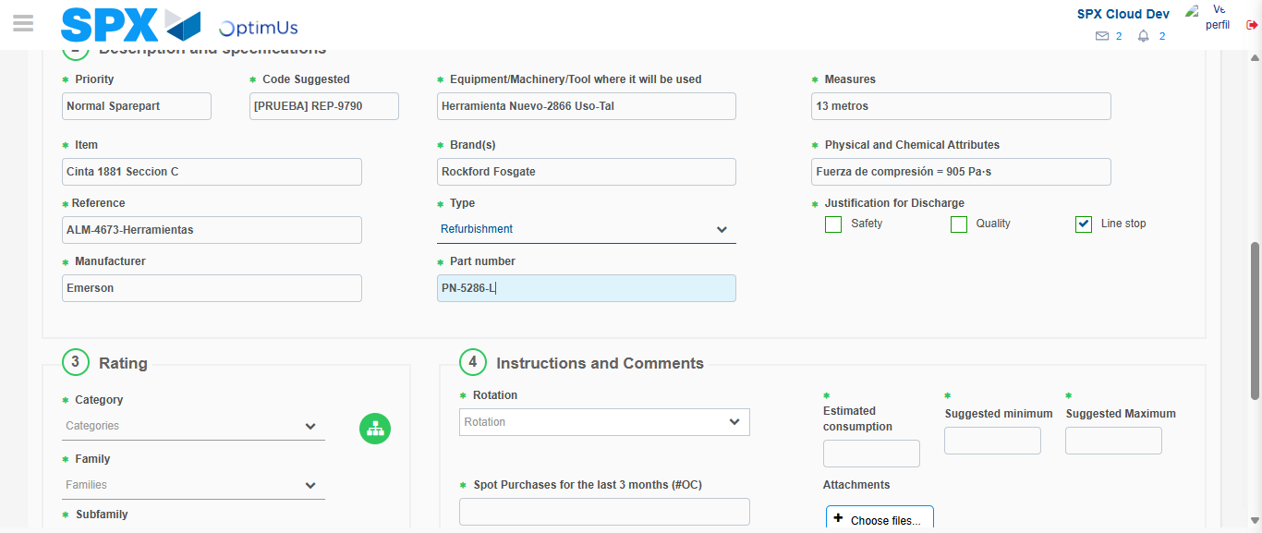Image file-name: QC_Testing-tc001_SPX_Dev5_Crear_Solicitud_Articulo_Almacen-1787938943566

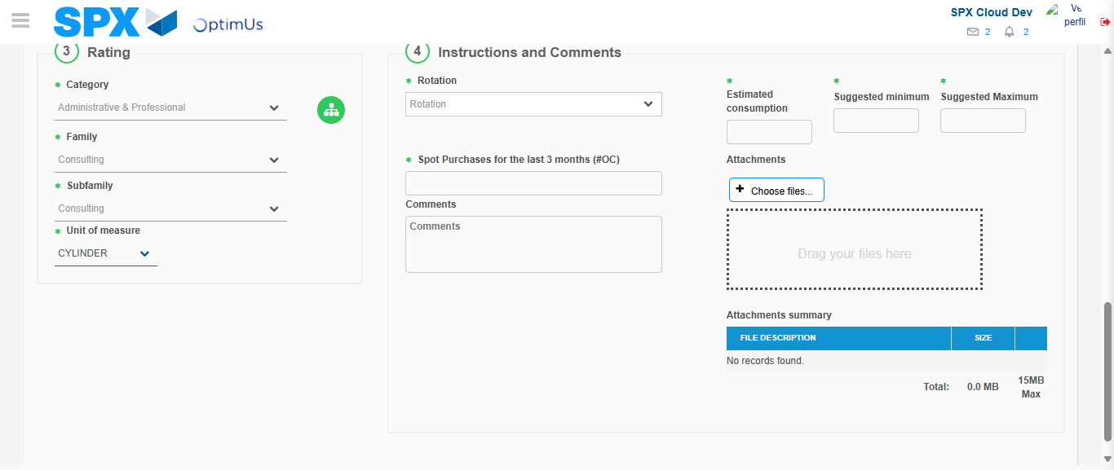Image file-name: QC_Testing-tc001_SPX_Dev5_Crear_Solicitud_Articulo_Almacen-1787938948055

Step 5 - Request New Item : Request Accepted
Image file-name: QC_Testing-tc001_SPX_Dev5_Crear_Solicitud_Articulo_Almacen-1787938904006

Image file-name: QC_Testing-tc001_SPX_Dev5_Crear_Solicitud_Articulo_Almacen-1787938904605

Image file-name: QC_Testing-tc001_SPX_Dev5_Crear_Solicitud_Articulo_Almacen-1787938929099

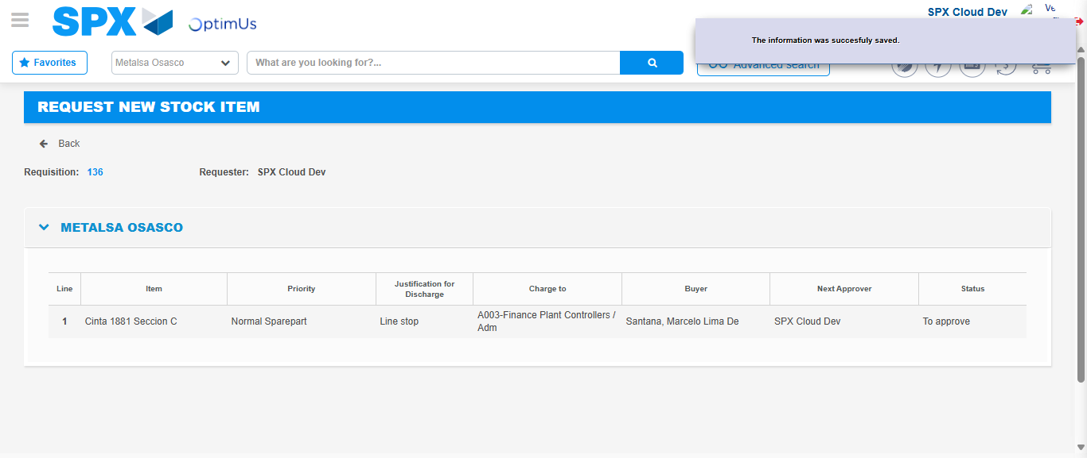Image file-name: QC_Testing-tc001_SPX_Dev5_Crear_Solicitud_Articulo_Almacen-1787938954858

Image file-name: QC_Testing-tc001_SPX_Dev5_Crear_Solicitud_Articulo_Almacen-1787938955048

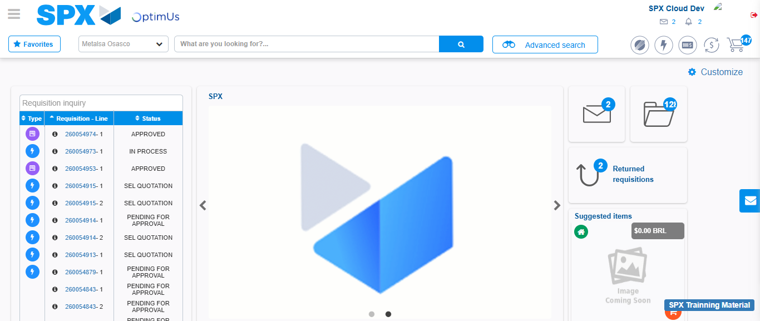Image file-name: QC_Testing-tc001_SPX_Dev5_Crear_Solicitud_Articulo_Almacen-1787938976240

Step 7 - Return to Main Page SPX : Return to Main Page SPX
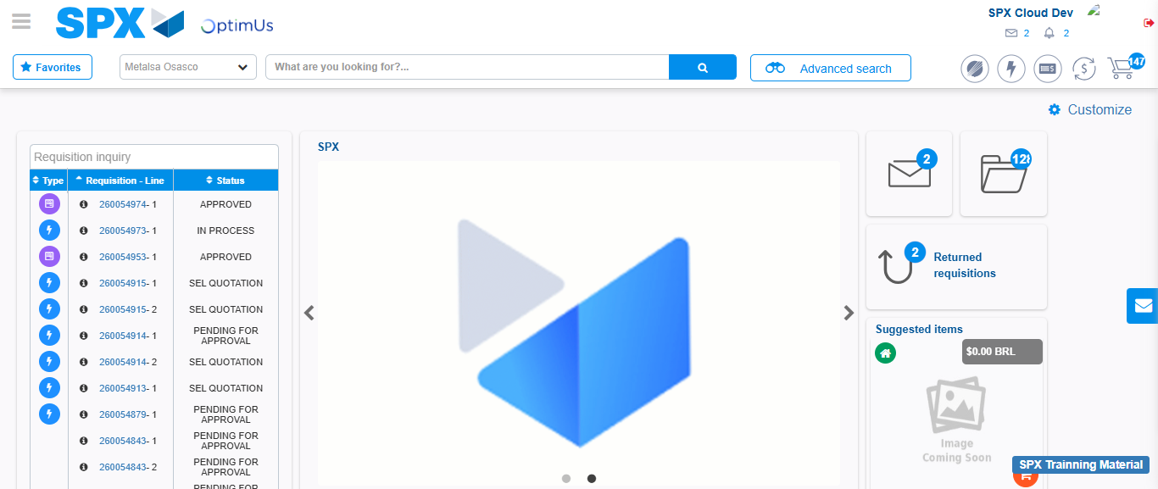Image file-name: QC_Testing-tc001_SPX_Dev5_Crear_Solicitud_Articulo_Almacen-1787938976509

